### Creating a New Repository on GitHub

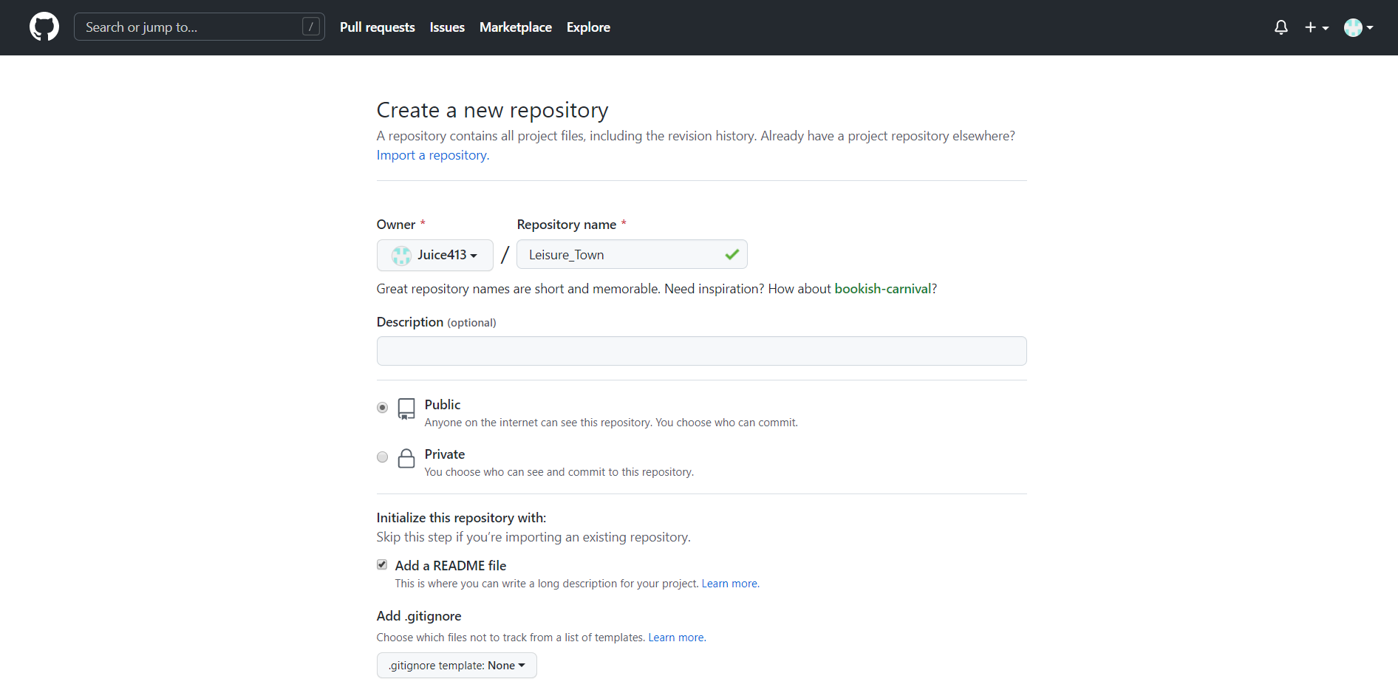

The repository will store the code we are about to upload, set the status to public, and allow team members to participate in code editing. Check Add a README File, and a README file will be automatically created in our project directory to explain our project.

### Open the project folder you want to upload, right-click the folder and select Git Base Here

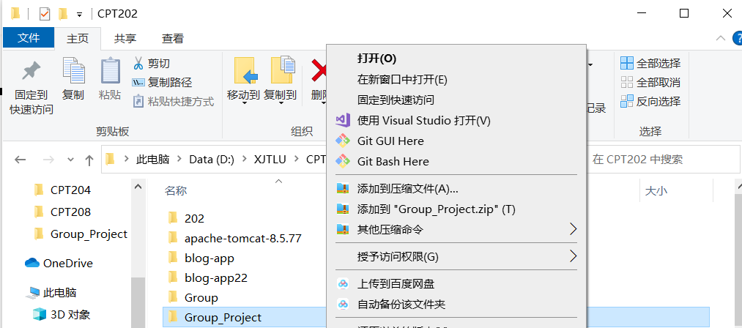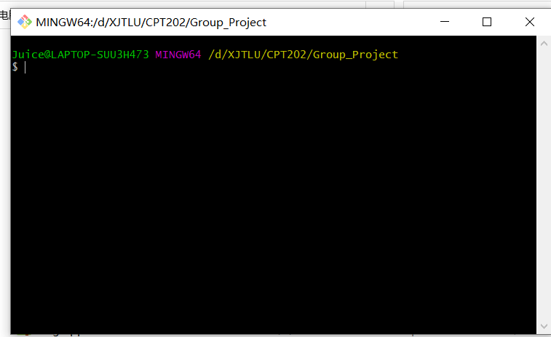

### Go to the GitHub repository and select the repository address to copy it，enter git clone "repository address" in GIT command window

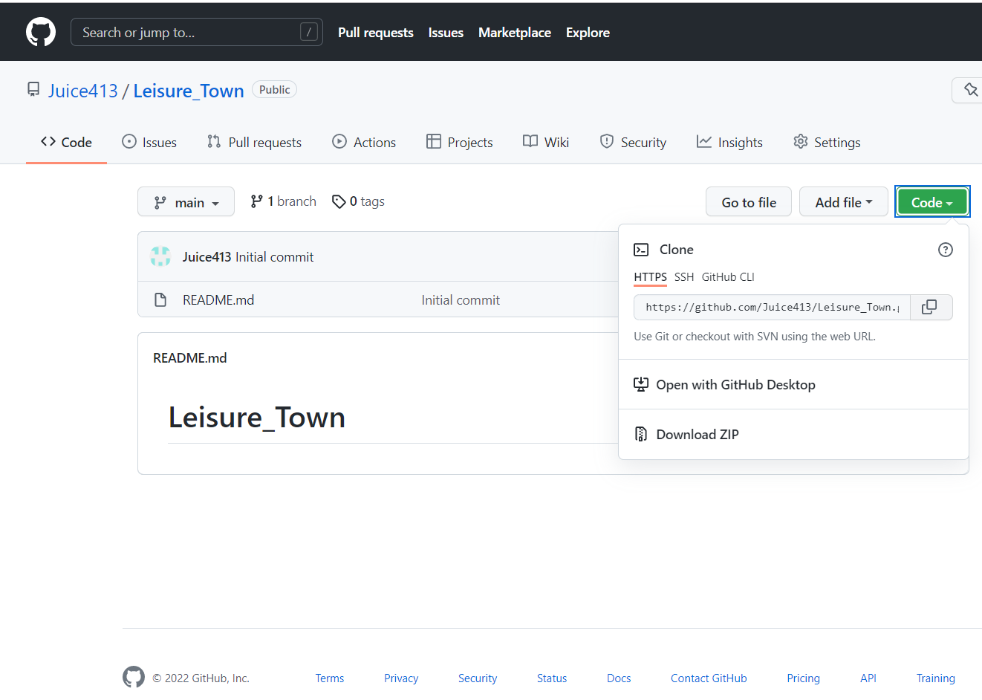 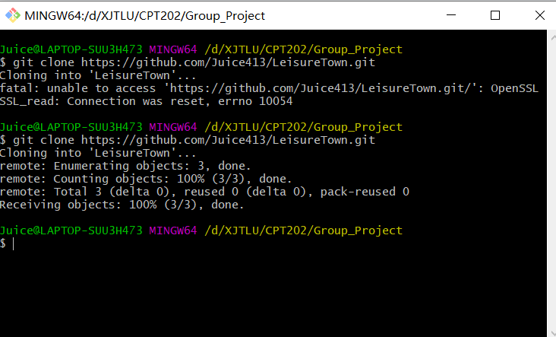

A folder with the same name as your repository will appear in your project folder

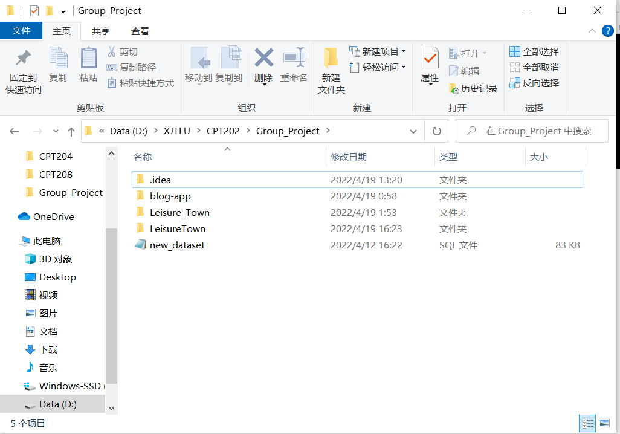

### Next, you need to copy the files you want to upload to this folder and type in the GIT command window:

cd folder_name

go to the file location



Type : git add. , enter (note that there is a '. ', this dot cannot be omitted)



Type : git commit -m "commit instructions"

(The purpose of submitting the explanation is to make myself or others clear about the purpose of uploading the file this time. Since the project may be modified later, the explanation of each modification is added for the convenience of reviewing the operation)



Type : git push -u origin main

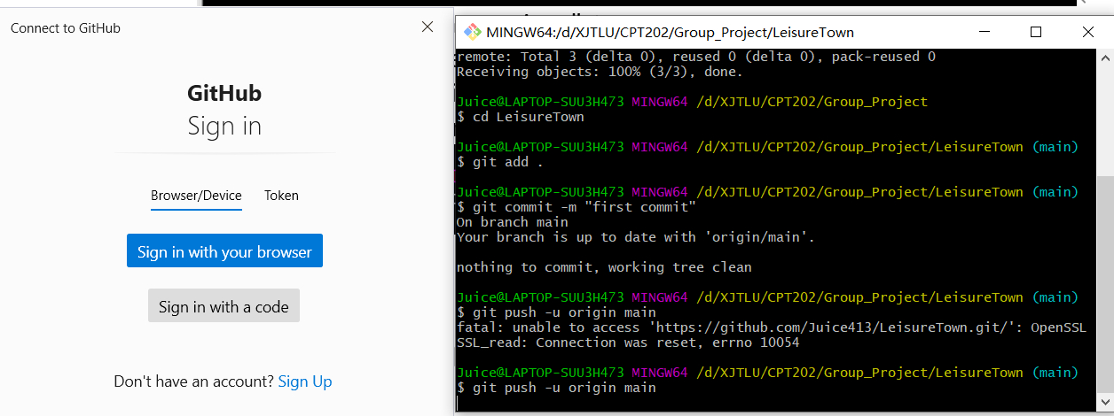

When executing this command for the first time, you will be asked to confirm your Github account password.

### When the file is uploaded, go to your GitHub repository to view the file you uploaded.

